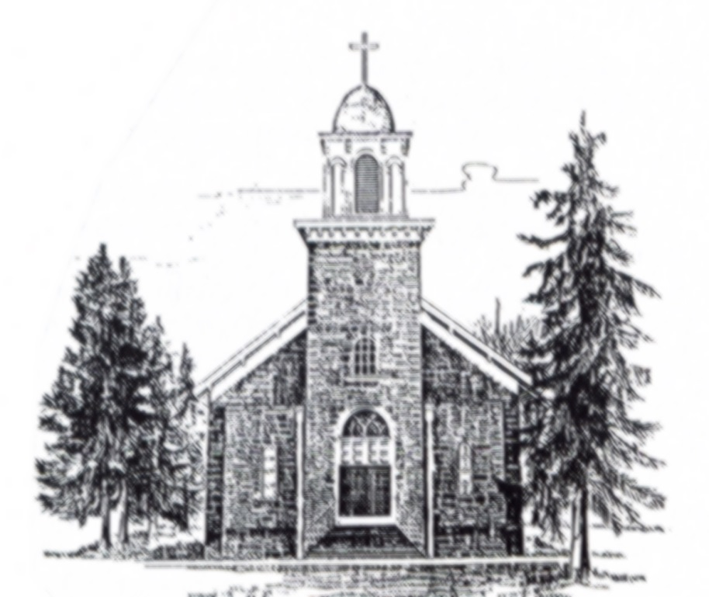

Immaculate Conception
Catholic Church, Fairbank
Religious Education
Parent/Student/Catechist
Handbook

2019 - 2020
ADDITIONAL PRAYERS AND DOCTRINE:
THE TEN COMMANDMENTS
- I am the Lord your God. Worship no other gods except for me.

- You shall not take the Lord’s name in vain.

- Remember to keep holy the Sabbath.

- Honor your father and your mother.

- You shall not kill.

- You shall not commit adultery.

- You shall not steal.

- You shall not tell lies against your neighbor.

- You shall not covet your neighbor’s wife or husband.

- You shall not covet your neighbor’s possessions.

THE SEVEN SACRAMENTS OF THE CHURCH
Baptism Reconciliation First Eucharist
Confirmation Matrimony Holy Orders
Anointing of the Sick
Dear Parents,
Welcome to another year of Religious Education at Immaculate Conception. We welcome you to fully participate in your child’s spiritual growth and development during this school year.
This handbook is to help acquaint you with the Immaculate Conception Religious Education Program structure. It details the program’s operating procedures, expectations, and concepts to be learned at each grade level. Please keep this booklet available for reference throughout the year. It is hoped that this booklet will help you participate more fully in the religious education of your child.
It is our hope that parents remember the promises they made at their child’s baptism: “We promise to raise this child in the faith into which they are being baptized,” and to “be the primary teacher of this child in matters of faith.”
Sincerely,
Father Ray Atwood, Pastor
Dan Cutsforth, Director of Religious Education
Lynda Cutsforth, Sacramental Director
Immaculate Conception Mission Statement
We the people of Immaculate Conception, being a community of caring people, will share our individual gifts, promote every person’s spiritual growth, support family life, and reach out to the world, as we live out the gospel mission of Jesus Christ and His Church.

GENERAL POLICIES
ATTENDANCE
Children in grades K – 4 will attend classes on Sunday mornings from 9:40 – 10:45. Parents dropping students off after Mass should make sure that Mass has ended. If Mass has not ended, there may not be an adult in the parish center. Children who are unsupervised in the parish center present several safety concerns. Please use the FRONT DOORS to enter for class.
Students in grades 5 – 10 will attend classes on Wednesday evenings from 7:00 – 8:00. Ninth and tenth graders attend every other Wednesday evening.
Regular attendance at class is expected at least one year prior to preparing to receive a sacrament, as well as the year of receiving the sacrament. Students should arrive at their classrooms promptly for the beginning of class so they do not disturb or delay learning.

CLASSROOM CONDUCT
Students will be expected to conduct themselves in a Christian manner while attending class. If a student does not behave in an appropriate way, the discipline policy on the following page will be enforced. The following building guidelines are expectations of all students:
- No gum, food, or beverages in class without the permission of the catechist.
- No objects or toys will be brought to class.
- Mutual respect will be shown among all people in the building.
- Students are expected to arrive to class on time.
- Students will follow the classroom expectations of their catechist.
ADDITIONAL PRAYERS/DOCTRINE
THE MEMORARE
Remember, O most gracious Virgin Mary that never was it known to anyone who fled to Your protection, implored Your help, or sought your intercession was left unaided. Inspired by this confidence, I fly unto You, O Virgin of virgins, my Mother. To You I come, before You I stand, sinful and sorrowful. O Mother of the Word Incarnate, despise not my petitions, but in Thy mercy hear and answer me. Amen.
HAIL HOLY QUEEN
Hail Holy Queen, Mother of Mercy, our life, our sweetness, and our hope. To Thee do we cry, poor banished children of Eve. To Thee do we send up our sighs, mourning and weeping in this valley of tears. Turn, then most gracious Advocate, Thine eyes of mercy toward us; and after this, in our exile, show unto us the blessed fruit of Thy womb, Jesus. O clement, O loving, O sweet Virgin Mary! Pray for us O Holy Mother of God, that we may be made worthy of the promises of Christ.
THE APOSTLE’S CREED
I believe in God, the Father Almighty, Creator of Heaven and earth; and in Jesus Christ, His only Son, our Lord; who was conceived by the Holy Spirit, born of the Virgin Mary, suffered under Pontius Pilate, was crucified, died, and was buried. He descended into Hell; on the third day He rose again from the dead. He ascended into Heaven and is seated at the right hand of God, the Father almighty; from there He will come to judge the living and the dead. I believe in the Holy Spirit, the holy Catholic Church, the communion of saints, the forgiveness of sins, the resurrection of the body, and life everlasting. Amen.
GRACE BEFORE MEALS
Bless us O Lord, and these Thy gifts, which we are about to receive, from Thy bounty, through Christ, our Lord. Amen
RELIGIOUS EDUCATION CURRICULUM OVERVERVIEW
The catechists in the Immaculate Conception Religious Education program are encouraged to use a variety of resources to promote the spiritual growth of each child. These resources are used to create an environment where each individual student is enabled to share their faith with others in the group.
Immaculate Conception will be using the “Call to Faith” textbook series published by Our Sunday Visitor. “Call to Faith” will be used in grades Kindergarten – 8. “Call to Faith” emphasizes the seven key precepts of the Catholic Church at each grade level in an age-appropriate manner. The seven key precepts of the Church taught at each level include: Creation, God, Jesus Christ, The Church, Christian Morality, The Seven Sacraments, and Salvation.
Students in ninth and tenth grade will be using Our Sunday Visitor’s Confirmation series titled “Call to Celebrate”.
Both of these curriculums provide parent materials that catechists will occasionally send home with students. In addition to materials that may be sent home, parents and students are encouraged to visit the Our Sunday Visitor website for materials and activities that supplement our curriculum. The URL for this website is: www.osvcurriculum.com. The website includes materials/activities for parents, students, and catechists.
The Safe Environment Curriculum is also taught at each grade level. Prior to each grade level session, a parent letter and permission slip will be sent home.
Parents are always welcome to visit their child’s classroom. If you wish to visit, we ask that you arrange this at least a week in advance. If you wish to regularly volunteer in a classroom, you must complete the Protecting God’s Children VIRTUS training and submit to a State of Iowa Background check.
STUDENT OPPORTUNITIES
Second grade students participate in a retreat prior to receiving their First Reconciliation. More information will be given to parents as the time approaches. Second grade students receive the Sacraments of Reconciliation and First Eucharist during this school year.
Field trip opportunities are occasionally presented to our students. Please be aware that parental permission is required for your child to participate in any outing that takes us away from the church grounds.
The Archdiocese of Dubuque Youth Rally is available to students in grades 9 – 12 every November. This event always takes place on the first Sunday of November. Information about this event will be sent home with high school students several weeks prior to the rally.
Teens Encounter Christ (TEC) is a weekend retreat available to seniors in high school. There are several TEC weekends throughout the year. Please look in the bulletin for upcoming dates or contact the Religious Education Office to seek information.
National Catholic Youth Conference (NCYC) takes place every two years (odd years) in Indianapolis, Indiana. To raise funds for these trips, participating students are asked to work at several fundraising events during the two years leading up to the trip. To get more information, contact Lynda in the Religious Education Office.
Various service opportunities are available to our students throughout the school year. There are opportunities to volunteer to work at breakfasts, Lenten meals, parish Fall Festival, parish Fish Fry, and many other events. We believe these service opportunities give students a life-long desire to share their time and talents with their church and community.

CONFIRMATION PROGRAM
Confirmation is a two year program beginning in ninth grade. The program continues and concludes in tenth grade. Ninth and tenth graders meet every other Wednesday evening from 7:00 – 8:00. Please look for the special schedule for 9th and 10th grade.
The decision to be a confirmed Catholic hopefully is a choice that young people have made through dialogue with their parents, other important people in their lives, and above all, God. Because of the importance of this sacrament in a young adult’s spiritual formation, attendance at class is essential.

NINTH GRADERS with more than one absence must make up any additional absences to stay enrolled in the Confirmation program. Classes will be made up with the Confirmation Director at a convenient time for both parties.

TENTH GRADERS must make up all classes that they miss. Students with any absences not made up will not be recommended for Confirmation. Classes will be made up with the Confirmation Director at a convenient time. In addition to classes, attendance is required at the Confirmation Enrollment Mass (usually in January), the Confirmation retreat, meetings, and certain service dates.

CATECHISTS
Kindergarten – Kim Weepie
First Grade – Jillian Sinnwell
Second Grade – Lynda Cutsforth
Third Grade – Lynda Cutsforth
Fourth Grade – Angel Martin
Fifth Grade – Emma Cutsforth, Brody Stark
Sixth Grade – Kaylee Kleitsch, Jocelynn Miller
Seventh Grade – Elaine Zimmerman
Eighth Grade – Mike and Michelle Weepie
Ninth/Tenth Grade - Lynda Cutsforth
Eleventh/Twelfth Grade - Bridget Stark, Tony Salisbury
ADDITIONAL INFORMATION

RELIGIOUS EDUCATION OFFICE
The Immaculate Conception Religious Education Office is located in the parish center. Come in the front doors, and it is the first office to the right. Stop in and acquaint yourself with the resources which are available. We would be happy to assist you in any way.

CLASSES
Classes are held in the Immaculate Conception parish center. If you wish to visit, we ask that you arrange it with the DRE or the catechist a week in advance. Your interest in the religious education program will show your child that their faith education is important to you.

WEATHER CANCELLATIONS
Weather cancellations will be broadcast on television stations KWWL and KCRG, as well as kwwl.com, and kcrg.com. If weather becomes inclement, please watch for cancellations. Our parish boundaries are quite large and some areas may be worse than others. There will be NO CLASS on Wednesday evening if school is cancelled or dismissed early because of inclement weather. Planned early dismissals or non-emergency early dismissals will not affect Religious Education classes.

ARRIVAL AND DISMISSAL
Classes will begin and end promptly at the scheduled times. We ask that students arrive on time so they do not disrupt a class already in progress. Students are discouraged from entering the building more than 10 minutes prior to the start of class. If your child will be absent, we would appreciate notification. Please use the parish center’s front entrance. The back doors will remain locked during classes.

ROLES AND RESPONSIBILITIES
STUDENTS
A great deal of the program’s success depends on the students. With mature behavior, students will be able to learn as much from each other as they will from the textbook about how to live as Jesus taught. For these reasons, and for the dignity of all, appropriate Christian behavior is expected from all students.
PARENTS
Much of what your child will learn from religious education classes will depend on your support and reinforcement at home. Please take time each week to discuss the lesson of that week. Learning prayers and church doctrine is time consuming and cannot be completed in the short class time each week. Parents are expected to work with their children at home. We provide a program to assist parents in their task of bringing their children up in the Catholic faith.
CATECHISTS
The role of your child’s teacher is to extend the presence of Jesus, the teacher of the Good News. The Good News includes the message of Jesus and His Church, the experience of the community with Christ and with each other, and service to each other. Our catechists will endeavor to be persons who lead and help children to grow in their faith. Catechists will complete a State of Iowa background check and VIRTUS training.
DIRECTOR OF RELIGIOUS EDUCATION
The DRE is responsible for assisting the students, the parents, and the catechists in performing their roles. The DRE is responsible for providing programs, content, and materials which will promote the spiritual growth of the students enrolled in the program.

CONTACT US
Religious Education Office – 319 – 635 – 2211
If there is no answer, please leave a message and we will return your call as soon as we can.
Parish Office – 319 – 635 – 2211
E-Mail – dbq078re@dbqarch.org
If your child will be absent, we would appreciate notification.

HELP FOR VICTIMS OF SEXUAL ABUSE
The Archdiocese of Dubuque has established a program of pastoral assistance to people who believe they or those in their care have been sexually abused as minors by clergy or other Church personnel. This assistance will include help in informing civil and Church authorities. Victim Assistance Coordinators are trained to facilitate access to appropriate professional mental health services, social service agencies, support groups, and/or individuals who can provide spiritual care. Any individual desiring help from this program is invited to call toll-free 800 – 803 – 6758 or 866 -319 4536 to report an allegation or receive assistance. This program is part of the “Policy for the Protection of Minors”.

PRAYERS AND DOCTRINE
Prayer is talking over our life with God. Prayer helps us cope with suffering and disappointment by reminding us that our problems are not permanent. Prayer brings joy and peace into our lives by removing the burden of inventing our own meaning for life. Prayer is the conscious side of our relationship with God. As parents, it is important to pray with your child and encourage them to pray privately.
It is an expectation that the prayers on this page will be learned by every second grader prior to receiving First Reconciliation.
SIGN OF THE CROSS In the name of the Father, and of the Son, and of the Holy Spirit. Amen. (Using right hand, touching forehead, then middle chest, then left chest, then right chest.)
THE LORD’S PRAYER Our Father, who art in Heaven, hallowed be Thy name. Thy kingdom come, Thy will be done, on earth as it is in Heaven. Give us this day our daily bread, and forgive us our trespasses, as we forgive those who trespass against us. And lead us not into temptation, but deliver us from evil. Amen.
HAIL MARY Hail Mary, full of grace, the Lord is with Thee. Blessed are You among women, and blessed is the fruit of Your womb, Jesus. Holy Mary, Mother of God, pray for us sinners, now and at the hour of our death.
GLORY BE Glory be to the Father, and to the Son, and to the Holy Spirit, as it was in the beginning, is now and ever shall be, world without end. Amen.
ACT OF CONTRITION My God, I am sorry for my sins with all my heart. In choosing to do wrong, and failing to do good, I have sinned against you whom I should love above all things. I firmly intend, with your help, to do penance, to sin no more, and to avoid whatever leads me to sin.
DISCIPLINE POLICY
The respect and dignity of all people is valued. Positive behavior helps all students by contributing to a climate of learning, loving, and living. It helps each student as it provides an environment to guide students to become a self-disciplined person.
Each catechist in their own classroom will set up and clarify goals for learning and establish classroom guidelines. These guidelines will be posted for students and shared with the DRE. Goal setting and positive consequences encourage students to choose appropriate behavior. Normal discipline problems will be handled by the classroom catechist. If there are ongoing or serious discipline issues, the catechist will dismiss a student to the Religious Education Office, and the following procedures will be followed:
- The student will meet one on one with the DRE.

- Following this meeting, the student will fill out a discipline form stating the problem and how to correct it in the future.

- The student and the DRE will sign the discipline form. At the discretion of the DRE, the student may return to class. The catechist will sign the form after class.

- The DRE will file the form in the Religious Education Office for the remainder of the year. When a student has two forms on file, the DRE will notify the student’s parents.

- Any subsequent removals from class will result in parent notification and a two week removal. Students will be allowed to return to class again after two weeks. A two week assignment for the student to work on at home will be given.

TABLE OF CONTENTS
p. 1 Letter to Parents
p. 1 Parish Mission Statement
p. 2 Attendance and Conduct Policies
p. 3 Discipline Policies
p. 4 Roles and Responsibilities
p. 5 Additional Program Information
p. 6 Curriculum Overview
p. 7 Student Opportunities
p. 8 Confirmation Program
p. 8 Catechists
p. 9 Office Contact Information
p. 9 Archdiocese Help for Sexual Abuse Victim Information
p. 10 Required Prayers for Second Grade
p. 11 Additional Prayers and Doctrine
p. 12 Additional Prayers and Doctrine
p. 13 Parent/Guardian Covenant (to be signed and returned)

Parent/Guardian Covenant
Recognizing our most solemn obligation to educate our children in the ways of the faith, we hereby enter into
this covenant with the Faith Formation Commission, administration, and staff of Immaculate Conception Catholic Church, to work cooperatively in providing for a quality program of faith formation for our children.
We agree to:
Provide good Christian example for our children
Communicate Christian values and attitudes
Provide opportunities to share in the sacramental life of the Church with our children
Provide for prayer opportunities for our children
Ensure the regular attendance of our child(ren) at class
Understand and accept the regulations set forth in the parent/student handbook
Volunteer our time when necessary for special projects

Parent/Guardian Signature______________________________________

Date ____________________

DRE__________________________________

Parish Life Coordinator____________________________________

FFC Chairperson____________________________________
Parents: Please cut this page out and return with your registration packet.

